10). Create a simple cloud software application for online super market using any Cloud Service Provider to demonstrate SaaS with the template of customer name, address, phone, email, items, quantity etc. with the item classification form.

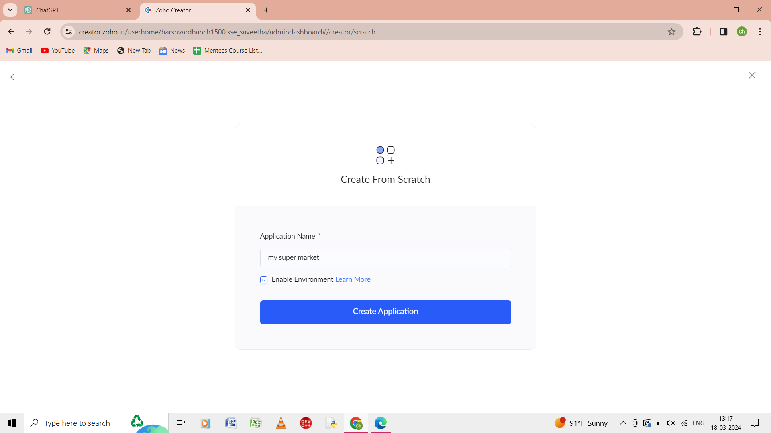

Step 1: from the scratch give the name of the application as my super market.

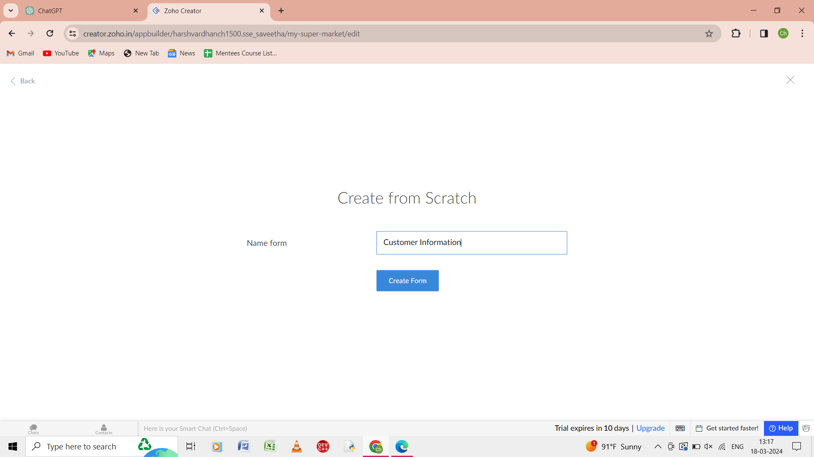

Step 2: from the scratch give the name of the form as customer information.

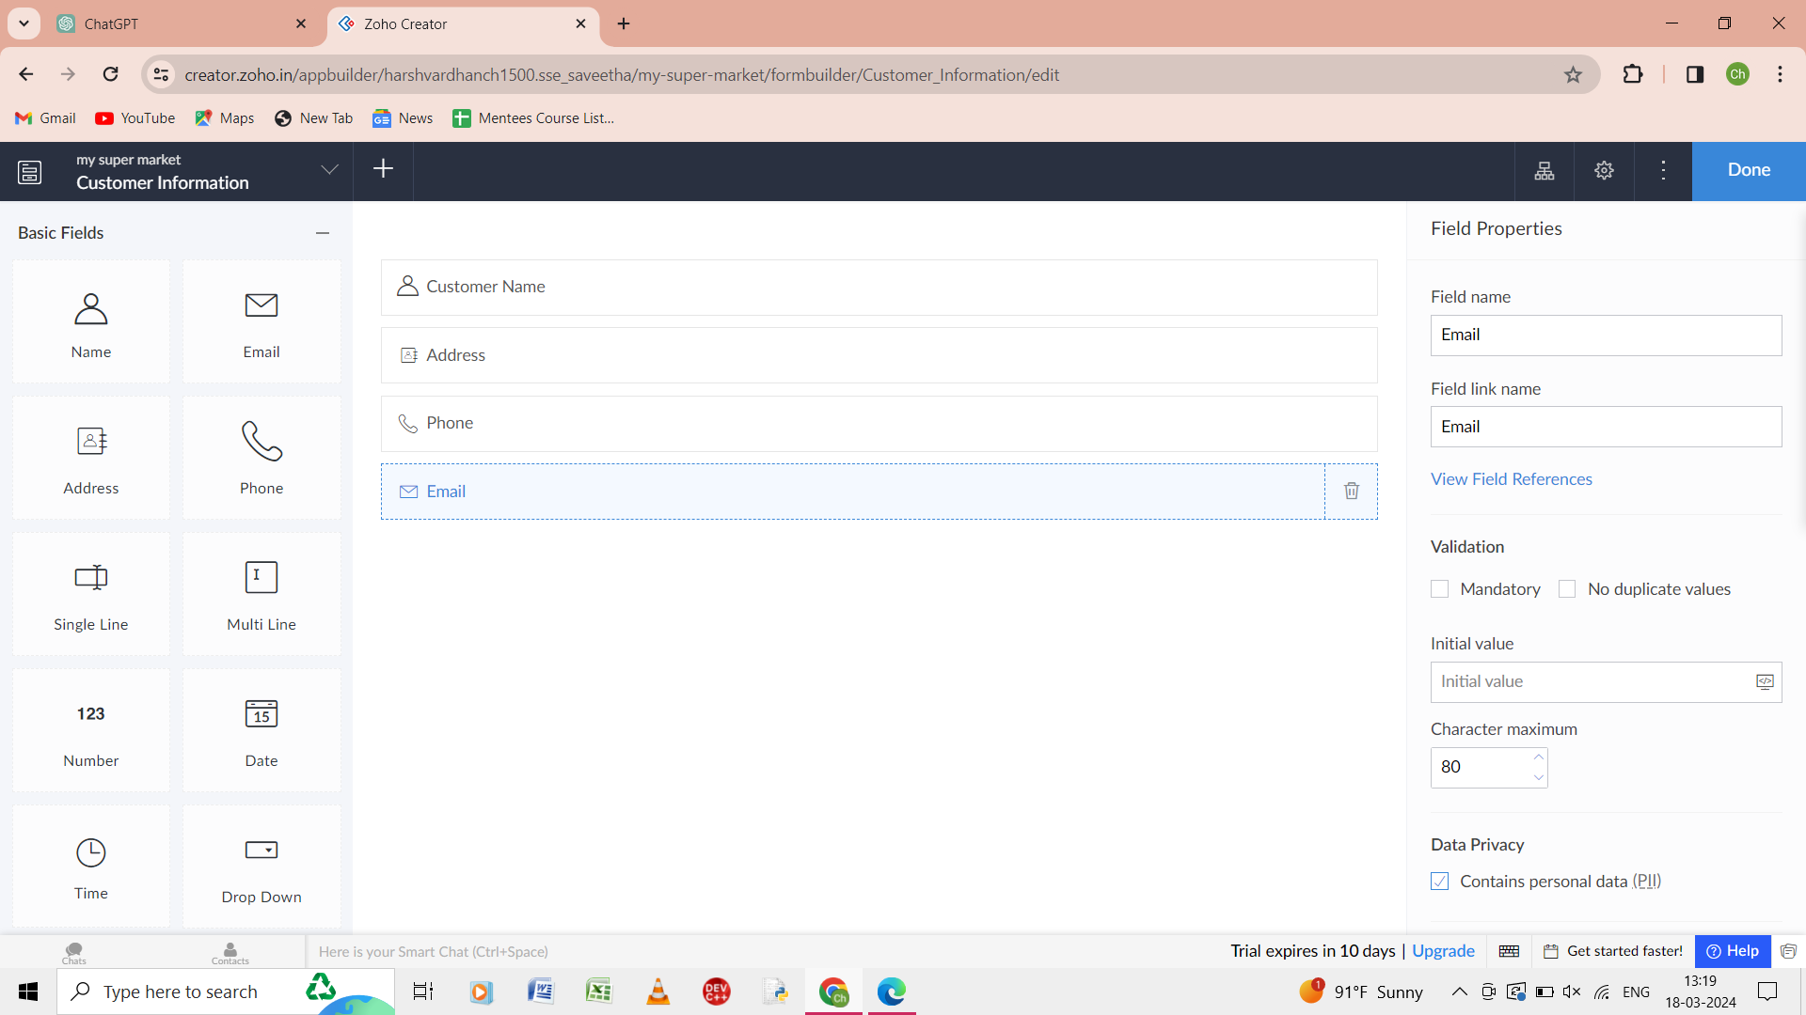

Step 3: in the form of customer information give the details as customer name, address, phone, email.

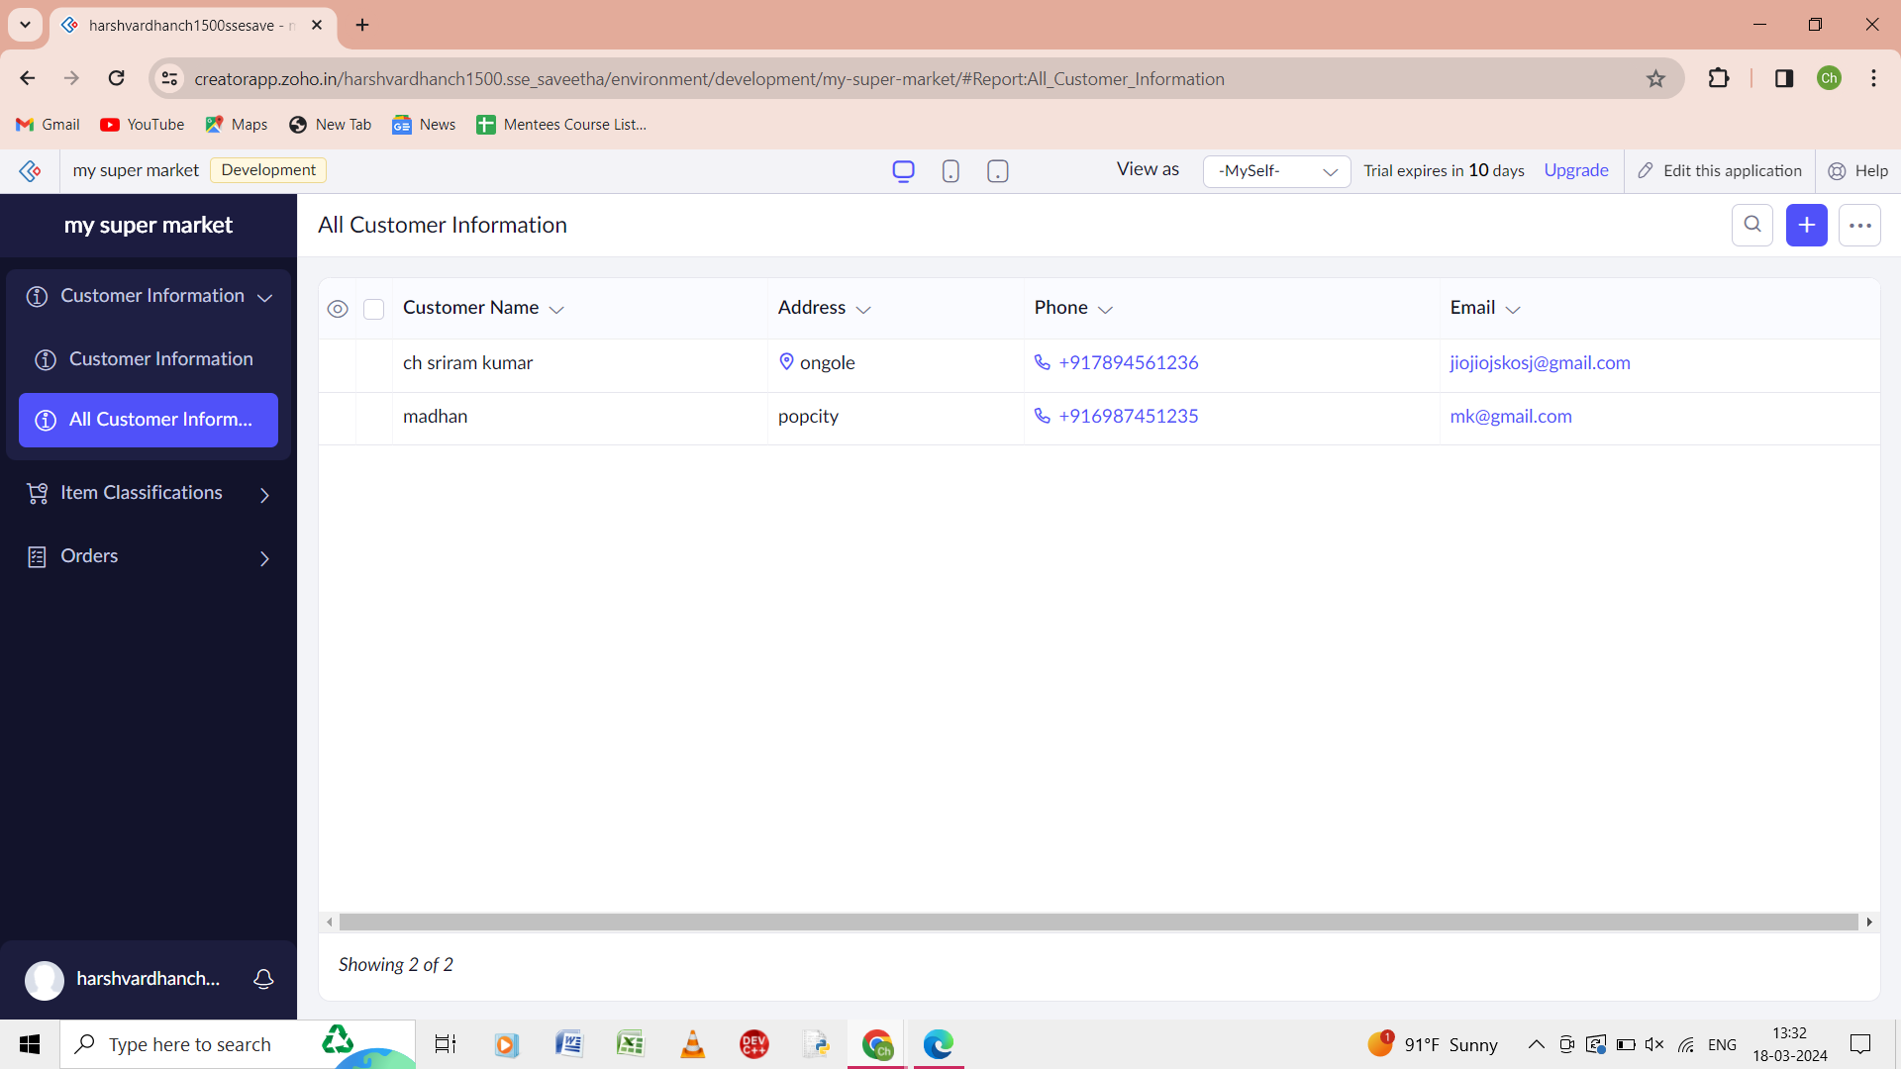

Step 4: the report of all the customer information is shown.

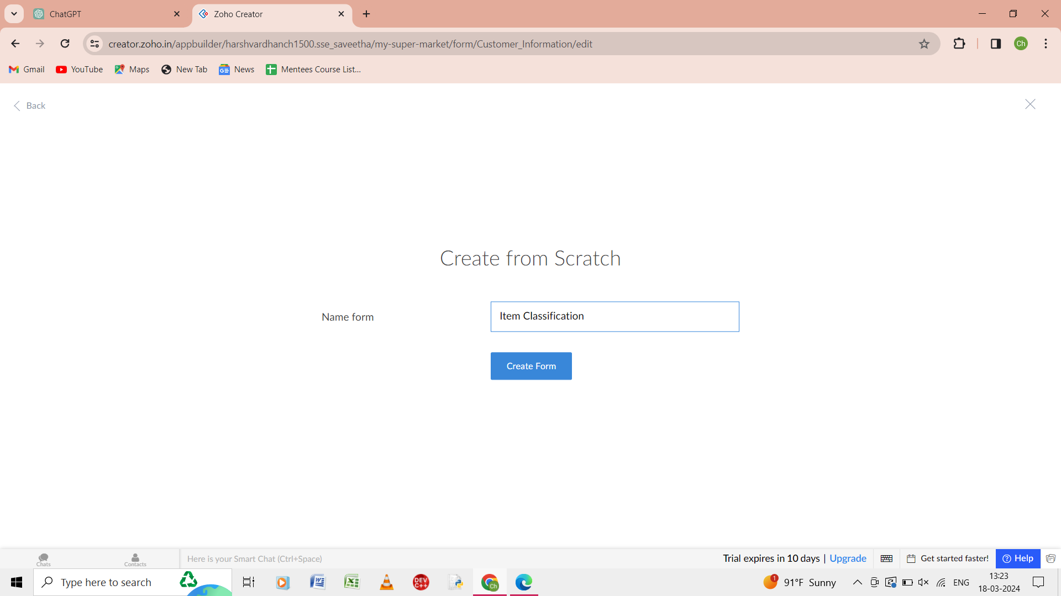

Step 5:from the scratch give name of the form as item classification.

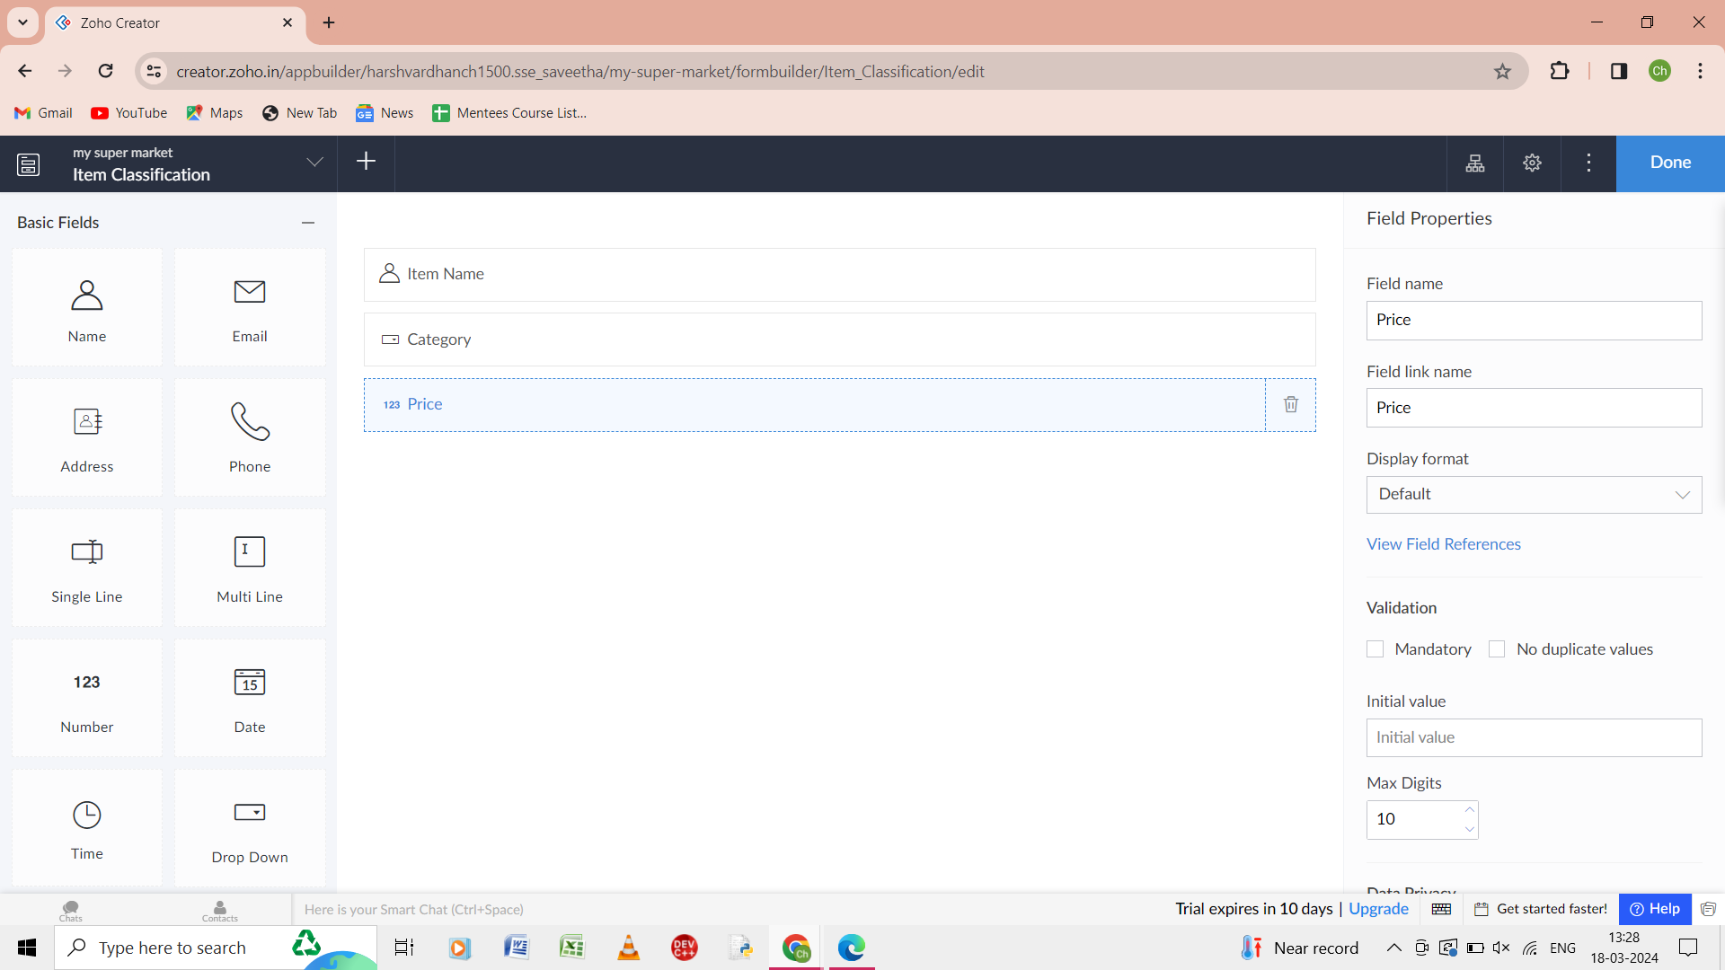

Step 6: in the form of item collection give the details as item name, category and price.

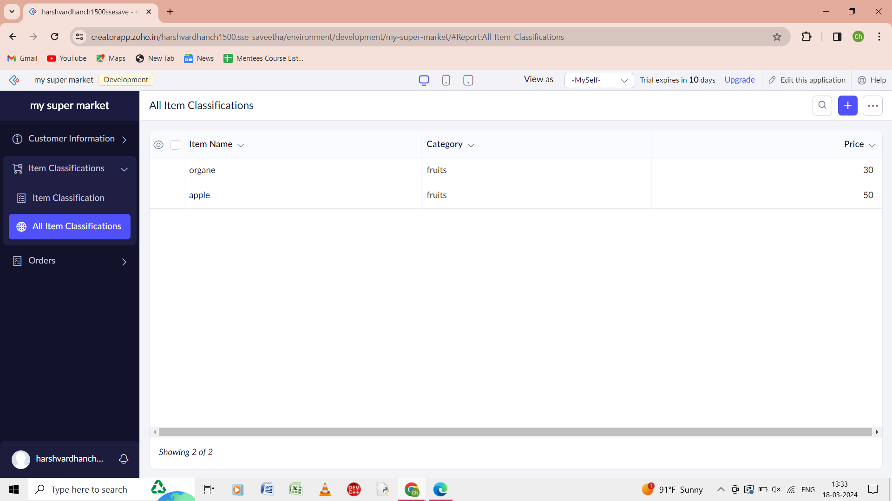

Step 7: the report all the items classification is shown.

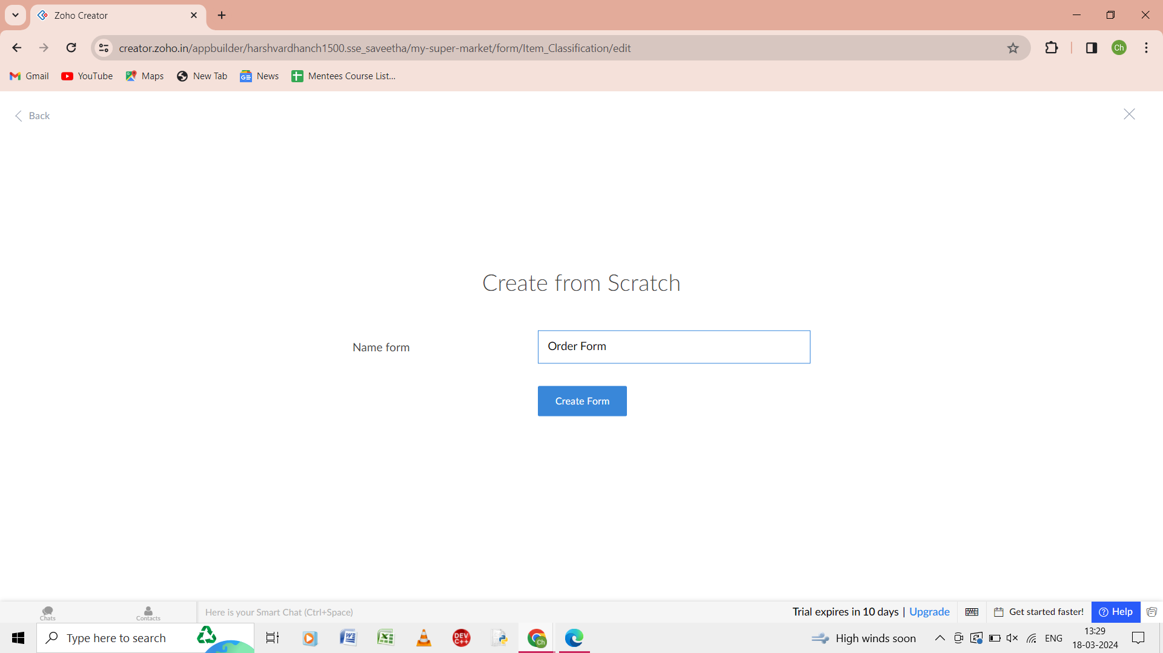

Step 8: from the scratch give the name of the form as order form.

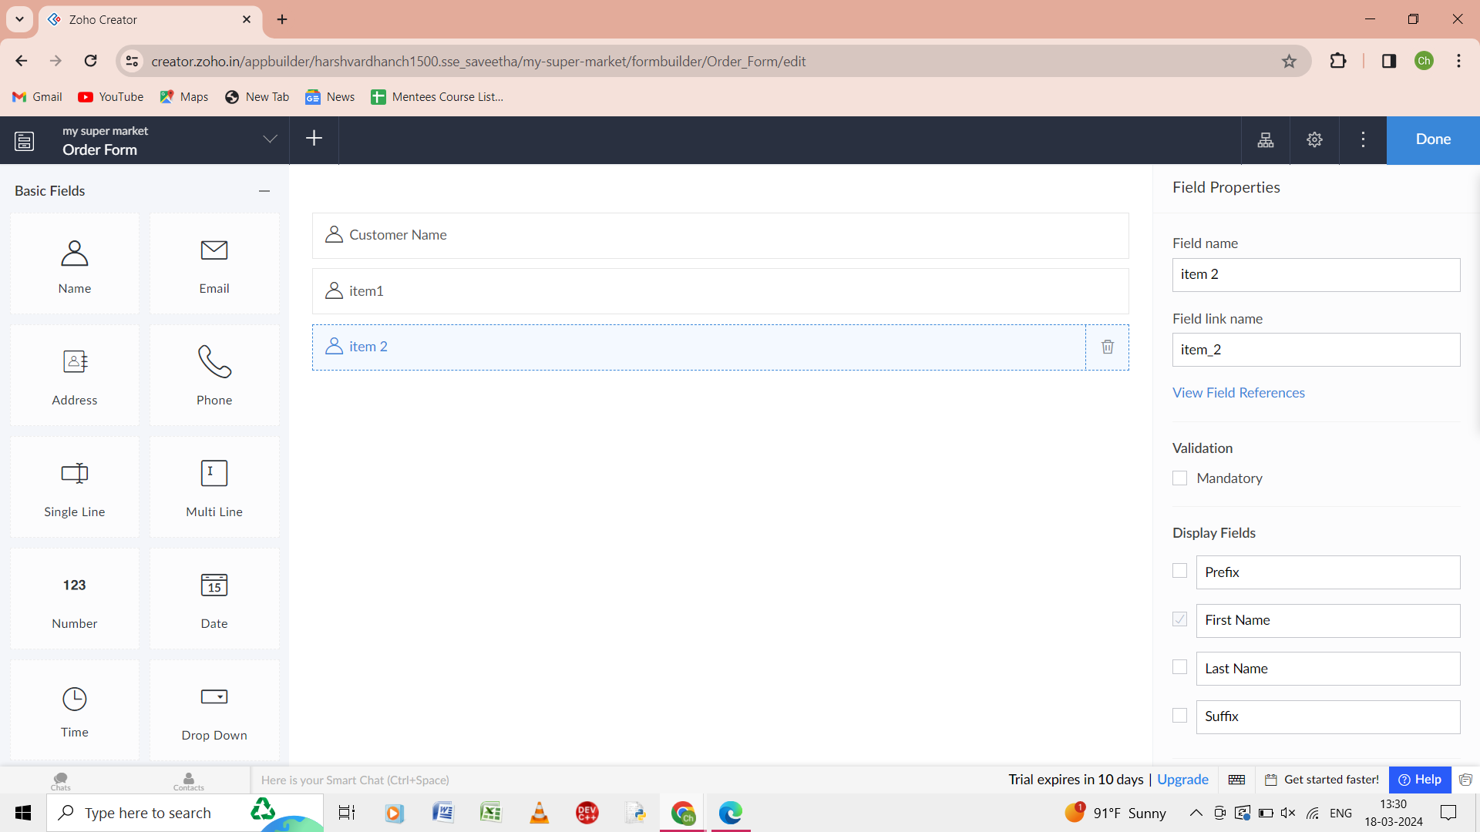

Step 9: in the form of the order give the details as customer name, item 1, item 2.

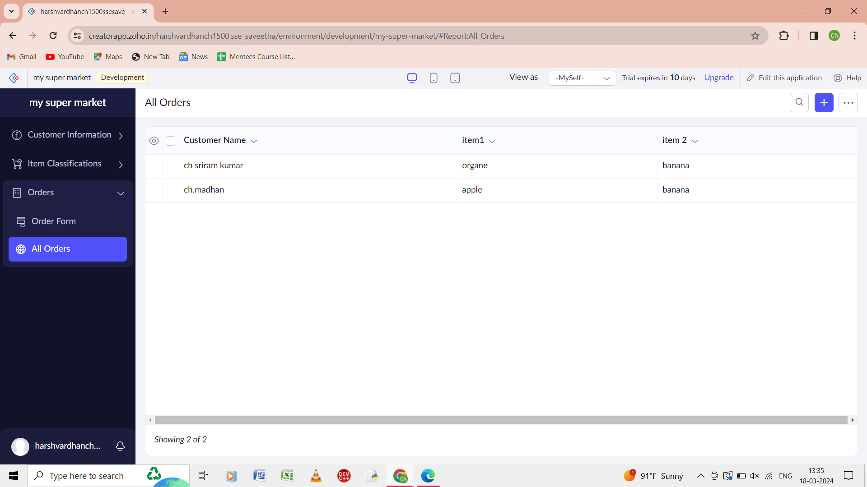

Step 10: the report of the all the order is shown.